ENGR 200 FALL, 2017

**A2: NUCLEAR CONTAINMENT BUILDING DESIGN**

**(basic program development)**

DUE: Sept. 12, 2017 by 11:59 pm, CDT POINTS: 40

**INTRODUCTION:**

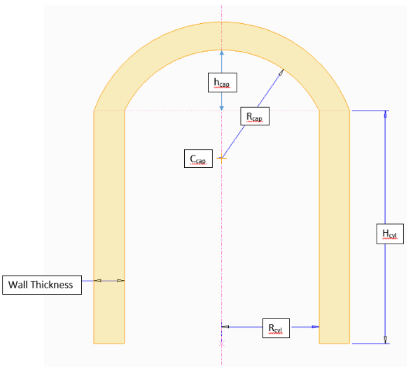You are a civil engineer working for a company that designs nuclear reactor containment buildings. The walls of the building are made from reinforce concrete, three feet thick. The containment building must be a cylinder with a spherical cap roof as illustrated to the right. The inner radius of the cylinder is given as **Rcyl**, and the inner radius of the spherical roof cap is given as **Rcap**. The height of the cylindrical portion is given as **Hcyl**.

**ASSIGNMENT:**

Write a C program that will allow the user to enter the radius of the cylinder **Rcyl**, the radius of the spherical cap **Rcap**, the wall thickness, and the inner volume of the building. The program will compute the cylinder height **Hcyl,** the spherical cap height **hcap**, the inner surface area of the building, and the total volume of concrete needed for the building. The program must use the power function for all variables that are raised to a power.

The equation for the inner volume of the cylinder is:

$V_{cyl}= πR_{cyl}^{2}H_{cyl}$ NOTE: Define $π$ as a symbolic constant.

The equation for the inner volume of the spherical cap is:

$V_{cap}=\frac{1}{3}πh_{cap}^{2}(3R_{cap}-h_{cap})$

where

$h_{cap}= R_{cap}-R_{cap}cosθ= R_{cap}\left(1-cosθ\right)$

NOTE: In C, the cosine function is written as cos(x), where x is any valid variable.

and $θ$ is computed by

$θ=\sin^{-1}\frac{R_{cyl}}{R_{cap}}$ or $θ=arcsin⁡(\frac{R_{cyl}}{R_{cap}})$

NOTE: In C, the arcsin function is written as asin(x), where x is any valid variable.

Using the above equations, the height **Hcyl** of the cylindrical portion of the building can be computed from:

$H_{cyl}=\frac{V_{cyl}-V_{cap}}{πR_{cyl}^{2}}$

The inner surface area of the building can be computed from:

$S_{inner}=S_{cyl}+S_{cap}=2πR_{cyl}H_{cyl}+2πR_{cap}h_{cap}$

The total volume of concrete required for the building is computed by subtracting the inner volume from the total outer volume of the building.

Test your program using Rcyl = 30 ft, Rcap = 45 ft, and an inner volume of 200,000 ft3.

**OUTPUT FORMAT:**

********************************************************

NUCLEAR CONTAINMENT BUILDING COMPUTATIONS

Enter inner volume of the building in cubic feet: x

Enter inner radius of the cylinder in feet : x

Enter inner radius of the spherical cap in feet : x

Enter wall thickness of the building in feet : x

RESULTS

Inner volume of the building = xxxxxx.x ft^3

Inner radius of the cylinder = xxxxxx.x feet

Inner radius of the spherical cap = xxxxxx.x feet

Wall thickness of the building = xxxxxx.x feet

Height of the cylinder = xxxxxx.x feet

Height of the spherical cap = xxxxxx.x feet

Inner surface area of the building = xxxxxx.x ft^2

Total volume of concrete needed = xxxxxx.x ft^3

********************************************************

**SUBMITTING PROGRAMS:**

Once you have your program working, exit the C compiler that you are using. Make sure that your source program file name conforms to the same naming convention that was used for program #1. An example for the second assignment is **1_2_elmer_fudd**.

**Note: Do not** change the extension, **.cpp,** that is at the end of the file name.

Submit your assignment (your source program) using the **Assignments** button in **Blackboard**. Remember to submit your C source program only. No other format will be accepted. If you make changes to your program and need to resubmit, rename the file such as **1_2_elmer_fudd_2** or **1_2_elmer_fudd_3**, etc. Then use the **Assignments** button in **Blackboard** to submit the new version. Only the most current submitted program version will be graded.